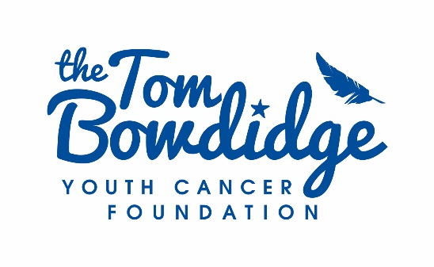
Grant Application

Applicant Information
Name:
Name of person filling in form on behalf of applicant:
Relationship to applicant:
Date of birth: | Mobile: |  | Phone:
Current address:
Town: | County: |  | Post Code:
Email address:

Reason for the application
Amount requested:

Save in exceptional circumstances this may not exceed £500
Reason for the application:

About You
Please tell us about yourself, why you are applying for a grant and how you would propose to use it, if successful:

Please provide a detailed breakdown of how the grant would be spent:

What other funding have you secured:

Please include documentary evidence to support planned spending e.g. quotes, invoices etc.

Details of referees – please provide two
Name:
Job title and/or relationship to you:

Address:

Email address:
Phone:

Referee 2
Name:
Job title and/or relationship to you:

Address:

Email address:

Phone:

the tom bowdidge Youth cancer foundation
Where did you hear about our work?

The Tom Bowdidge Youth Cancer Foundation would like to share the journey of the teenagers and young people we have supported with its supporters and donors. This information would be shown on the charity’s social media and website. If you would like to share your story please email nikkibowdidge@tombowdidgefoundation.org (under the Data Protection Act 1998).

Please tick here if you agree to us sharing your story

Bank Details

Please provide your bank details for use should your application be accepted
Bank Name: |  | Account Name:
Account Number: |  | Sort Code:
SIGNATURE
Please sign and date below to confirm all the information provided is correct
Please note that if you are under 18 years of age this form must be counter signed by your parent or guardian.

To the best of my knowledge all the information provided on this application is correct.
Signature: |  |  | Date:
Parent/Guardian Signature: |  |  | Date:

Please return this application by post to 9 Firmins Court, West Bergholt, Colchester, Essex, CO6 3BQ or nikkibowdidge@tombowdidgefoundation.org
The Tom Bowdidge Youth Cancer Foundation is registered with the Charity Commission under Number 1156553

We use your personal information to give you the information, support, services or products you ask for.
We do not sell, share or swap your information with any third party for the purpose of them sending marketing information.
When we collect your personal information, we use strict procedures and security features to prevent unauthorised access. However, no data transmission over the internet is 100% secure. As a result, while we try to protect your personal information, The Tom Bowdidge Foundation cannot guarantee the security of any information you transmit to us and you do so at your own risk. If you're 16 or under in some circumstances we may need to know if you are aged 16 or under and may refuse certain services or refuse certain services unless we have your parent/guardian’s permission.
You can ask us what information we hold about you by contacting nikkibowdidge@tombowdidgefoundation.org or call 07771646654

