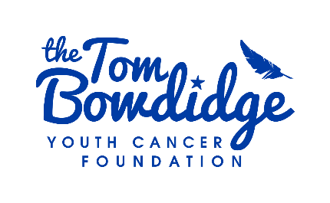
Grant Application
Office Use Only Date Received: Date Paid:
Fund:
APPLICANT INFORMATION
Name of person filling in the form on behalf of the applicant:
Young person details
Title:
First Name:
Surname:
Date of birth:
Age:
Gender: Ethnicity:
Nationality: Religion:
Young person's Current Address:
Town: County: Postcode:
Mobile Number:
Marital Status:
Are you in receipt of benefits?
Email Address:
Type of Cancer:
Date of Diagnosis: Treatment Hospital:
Is this a relapse/ Secondary Cancer Diagnosis?:
REASON FOR THE APPLICATION
Amount Requested:

Save in exceptional circumstances, this may not exceed £500
Reason for the application:

ABOUT YOU
Please tell us about yourself, why you are applying for a grant and how you would propose to use it, if successful:

Please provide a detailed breakdown of how the grant would be spent:

Have you applied to any other charities for financial support?

If yes, please name the charities that have helped you & how they supported you.

Please include documentary evidence to support planned spending e.g. quotes, invoices, etc

PLEASE PROVIDE DETAILS OF YOUR HEALTHCARE PROFESSIONAL* required
Title:
First name:
Last name:
Job title:
NHS Email address:
Phone:
THE TOM BOWDIDGE YOUTH CANCER FOUNDATION
Where did you hear about our work?

The Tom Bowdidge Youth Cancer Foundation runs regular campaigns to help raise funds to support young people and families like yours. This would mean sharing a photo of yourself alongside your story. Is this something you agree to?

Please comment Yes or No
*required

The Tom Bowdidge Youth Cancer Foundation shares stories on social media, the website, and with donors and funders about how their donations have made a difference for young people with cancer. Please confirm if you would be happy for us to share your story and/or a photo.

Please comment Yes or No
*required

BANK DETAILS
Please provide your bank details for use should your application be accepted
Bank Name: Account Holder's Full Name:

Account Number: Sort Code:

SIGNATURE
I certify that the above information is accurate, and I understand that any misleading or false information will result in Tom Bowdidge Youth Cancer Foundation terminating this application for support.

Please note that if you are under 18, this form must be countersigned by your parent or guardian.
Signature:

Date:
Parent/Guardian Signature:

Date:
Please return this application by post to 9 Firmins Court, West Bergholt, Colchester, Essex, CO6 3BQ or nikkibowdidge@tombowdidgefoundation.org

We use your personal information to provide the information, support, services, or products you request.
We do not sell, share, or swap your information with any third party to send them marketing information.
When we collect your personal information, we use strict procedures and security features to prevent unauthorised access. However, no data transmission over the internet is 100% secure. As a result, while we try to protect your personal information, the Tom Bowdidge Youth Cancer Foundation cannot guarantee the security of any information you transmit to us, and you do so at your own risk. If you're 16 or under, in some circumstances, we may refuse certain services unless we have your parent/guardian’s permission.

You can ask us what information we hold about you by contacting nikkibowdidge@tombowdidgefoundation.org or calling 07771 646654
The Tom Bowdidge Youth Cancer Foundation is a charity registered in England and Wales (1156553)
9 Firmins Court, West Bergholt, Colchester, Essex, CO6 3BQ
facebook.com/thetombowdidgefoundation
instagram.com/tombowdidgefoundation





